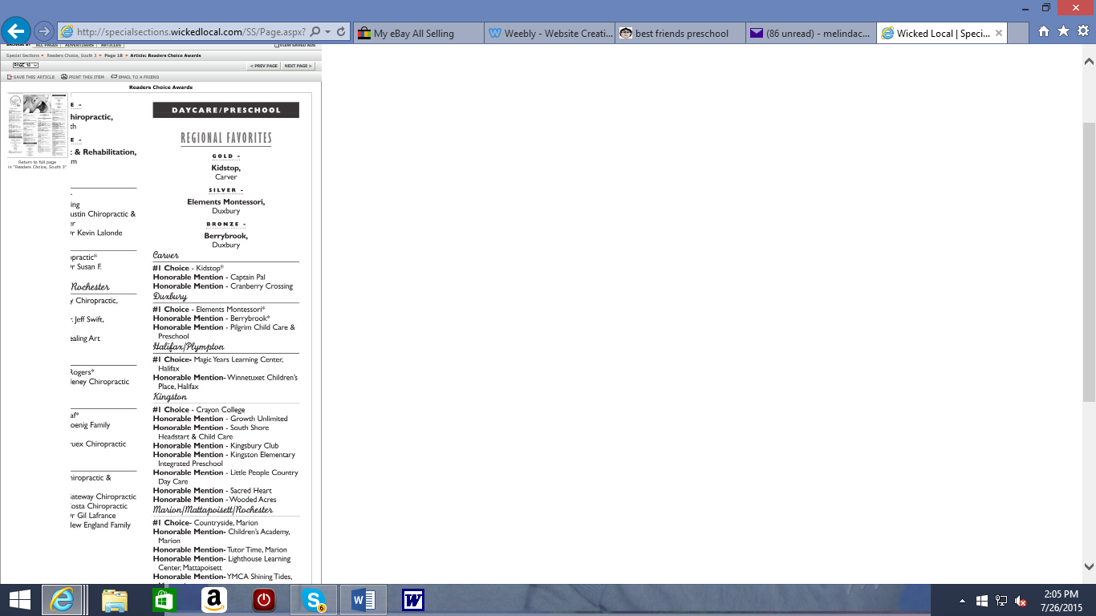

[](http://www.google.com/url?sa=i&rct=j&q=&esrc=s&source=images&cd=&cad=rja&uact=8&ved=0CAcQjRxqFQoTCLG9orKy-cYCFceCPgodXiwF-A&url=http%3A%2F%2Ffcnsma.org%2F796%2F&ei=iiK1VbHQCceF-gHe2JTADw&bvm=bv.98717601,d.cWw&psig=AFQjCNF2qp38Praz8fo7sLaHu6OztZ2LQA&ust=1438020612505470)

[](http://www.google.com/url?sa=i&rct=j&q=&esrc=s&source=images&cd=&cad=rja&uact=8&ved=0CAcQjRxqFQoTCKL_xMGy-cYCFQU_PgodxL0GoQ&url=http%3A%2F%2Ffcnsma.org%2F796%2F&ei=qiK1VaKCC4X--AHE-5qICg&bvm=bv.98717601,d.cWw&psig=AFQjCNF2qp38Praz8fo7sLaHu6OztZ2LQA&ust=1438020612505470)